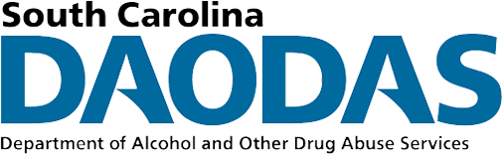
DAODAS STANDARD SURVEY BATCH COVER SHEET

SURVEY VERSION (check box): ☐ Middle School ☐ High School
COUNTY: Click or tap here to enter text.
PROGRAM: Click or tap here to enter text.
GROUP NAME (make sure pre and post names match): Click or tap here to enter text.
PRE OR POST SURVEY? Choose an item.
NUMBER OF SURVEYS SUBMITTED IN THIS BATCH: Click or tap here to enter text.
DATE OF SURVEY: Click or tap here to enter text.
NUMBER OF SESSIONS OF THIS PROGRAM DELIVERED TO THIS GROUP: Click or tap here to enter text.

HAVE YOU REVIEWED BATCH TO ENSURE EACH SURVEY’S PAGES ARE IN ORDER? Choose an item.
HAVE YOUR REVIEWED BATCH FOR ALL OTHER ISSUES (NO STAPLES, CLEAR STUDENT ID CODES ON EACH PAGE, ETC.?) Choose an item.

DO YOU WANT A REPORT AT THIS TIME? * Choose an item.
*COUNTIES MAY REQUEST ONE REPORT PER PROGRAM, PER YEAR (NOT COUNTING THE YEAR END REPORT).

STAFF CONTACT PERSON:
PHONE:
EMAIL:
STAFF SIGNATURE: _________________________________________________

