August 2014



**How to Conduct a Needs Assessment**

**A Guidance Document for County Commissions**

**SC Department of Alcohol and Other Drug Abuse Services**

This guide was adapted by the South Carolina Department of Alcohol and Other Drug Abuse Services (DAODAS) from a draft version of the Strategic Prevention Framework (SPF): A Guide for Michigan Communities, written by Michigan’s Bureau of Substance Abuse and Addiction Services and the Pacific Institute for Research and Evaluation. The Michigan guide was created from material from the Maine Department of Health and Human Services, and Nevada and North Carolina SPF SIG projects. INTRODUCTION

In 2004, the US Substance Abuse and Mental Health Services Administration’s (SAMHSA) Center for Substance Abuse Prevention (CSAP) began to promote the use of a five-step planning and implementation model called the Strategic Prevention Framework (SPF). CSAP has disseminated the SPF across the country by providing SPF State Incentive Grants (SPF SIGs) to states, jurisdictions, and tribal nations. South Carolina received a SPF SIG award from CSAP in July 2009 and will continue to use the SPF model throughout the state of South Carolina to guide planning of local and state prevention strategies.

The SPF promotes data-driven decision-making, with an emphasis on epidemiological data and a population-based perspective. In other words, prevention must be evidence-based and must reach beyond small groups of people who participate in prevention programs. Prevention must be aimed at the whole community, across the lifespan. The five steps of the SPF are:

1. Profile population needs, resources, and readiness to address needs and gaps;
2. Mobilize and/or build capacity to address needs;
3. Develop a comprehensive strategic plan to meet those needs;
4. Implement evidence-based prevention programs, policies, and practices; and
5. Monitor, evaluate, sustain, and improve or replace those that fail.

The SPF also emphasizes the importance of infusing two overarching themes, cultural competence and sustainability, throughout the five steps. The SPF challenge is to move from the moderate success afforded by idiosyncratic program implementation to employing collaborative strategies that yield broader population or community change. This requires engagement in systemic coordination and sustained effort at both state and county levels. The continuous process has been depicted as follows:



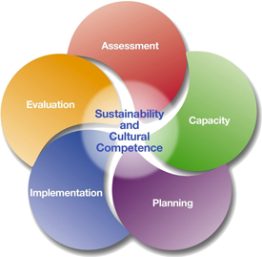

The purpose of this Guide is to assist you through the implementation of the first step of the SPF at the county level. The next section provides an overview of the SPF by answering some common questions about the framework. The Guide will then take you step by step through the activities associated with Needs Assessment. Throughout this process, the Guide will help you understand what you are doing and why you are doing it. A glossary of terms related to needs assessment is provided at the end of this document.

We look forward to working with you to assess your county’s needs and capacity, and to develop, implement and monitor a strategic plan that will increase your ability to effectively prevent substance abuse in your county.

# COMMON QUESTIONS ABOUT THE STRATEGIC PREVENTION FRAMEWORK[1]

**How is the Strategic Prevention Framework Different from Other Approaches?**

The five steps of the framework are very similar to other approaches for prevention planning. Efforts such as CSAP’s “Achieving Outcomes,”“Getting to Outcomes,” and to a large degree, “Guidelines and Benchmarks for Prevention Programming” endorse this program planning approach. However, an important difference is the high degree of emphasis that the SPF places on targeting **population-level change** through **outcomes-based prevention** focusing on both *consequences* and *consumption*.

**What is Population-Level Change?**

Population-level change focuses on change for entire populations. By entire populations, we mean collections of individuals who have one or more personal or environmental characteristics in common. The SPF process expects us to work towards influencing whole communities, not just 20, 50, or 200 individuals who participate in a prevention program. In this way, the framework is a public health approach to prevent and reduce substance-related problems.

**What is Outcomes-Based Prevention?**

Outcomes-based prevention is an approach to prevention that focuses on reducing the negative consequences of substance abuse **by using data to identify consequences, consumption patterns, and causal factors associated with substance abuse.** It is based on the explicit assumption that communities must know what their problems are, which factors cause those problems in their communities, and which strategies are effective in reducing those risk factors and underlying conditions. It is a logical approach, grounded in data collection and clear linkages between consequences, consumption, risk factors and underlying conditions, and strategies.

*Consequences* are defined as the social, economic and health problems associated with the use of alcohol, tobacco, and illicit drugs. Examples are things such as alcohol-related car crashes and deaths, cirrhosis of the liver, fetal alcohol syndrome, tobacco-related cancers and respiratory diseases, and drug overdose.

*Consumption* includes overall consumption, acute or heavy consumption, consumption in risky situations (e.g., drinking and driving) and consumption by high-risk groups (e.g., youth, young adults, and pregnant women). The way in which people drink, smoke and use drugs is linked to particular substance-related consequences.

*Risk factors and underlying conditions* are the factors that cause or contribute to substance-related consequences and consumption in communities. (See the box below for examples.) When creating a SPF strategic plan, we need evidence not only for the consequences/consumption patterns, but also for the risk factors and underlying conditions we believe are the causes of the substance abuse. It is through positively influencing risk factors and underlying conditions that we achieve population-level changes in substance consumption and consequences.

**Examples of Risk Factors and Underlying Conditions**

* Availability of substances (retail and social)
* Promotion of substances
* Social norms regarding substance use
* Enforcement of alcohol, tobacco, and drug laws and policies

*Source: examples from "A General Causal Model to Guide Alcohol, Tobacco and Illicit Drug Prevention: Assessing the Research Evidence." Multi-State Technical Assistance Workshop. Washington, DC. March 16, 2006.*

Once risk factors and underlying conditions are identified, we select appropriate **strategies** to address the issues in our communities. The basic outcomes-based prevention model (Figure 1) is as follows:

Figure 1.

**Consequences and Consumption (Substance Abuse and Related Problems)**

**Strategies, Programs, Practices & Policies**

**Risk and Protective Factors & Underlying Conditions**

**Planning, Monitoring, Evaluation and Re-planning**

Your role in outcomes-based prevention is to:

* Use data to identify your priority problem(s);
* Use data to understand more about your priority problem(s);
* Use data to identify and prioritize the risk factors and underlying conditions that are related to the problems;
* Choose ***effective*** strategies to address the risk factors and underlying conditions, and implement those strategies with fidelity;
* Monitor/evaluate your implementation fidelity and your outcomes.

This Guide is intended to help you employ outcomes-based prevention to address substance use and abuse in your county.

# 

# STEP 1: NEEDS ASSESSMENT

The first step in the SPF is needs assessment. A needs assessment helps you prioritize substance abuse problems, ground planning in actual needs and resources, and identify gaps for implementing solutions to address the needs. The assessment should give you concrete information about your county that will help you form a comprehensive picture or profile to guide the rest of your planning process. Without the breadth and depth of comprehensive data collection, your prevention plan may overlook some problems, and focus the county’s resources on inadequate interventions. Data also can illuminate previously unidentified challenges and resources. The better you understand your county and the more complete your data collection, the more likely your prevention project will be successful.

In addition to increasing understanding of substance abuse in your county, completing the SPF needs assessment will allow your county to target its resources and maximize its impact on substance abuse. For example, are you targeting the appropriate age groups? Are there certain towns or geographic areas on which you should focus? Where could your efforts be more effective?

The assessment process will function as a tool in a larger effort to strengthen your prevention infrastructure. **It is designed to be a county-wide effort and not the sole responsibility of the prevention specialist or prevention staff.** It will help collaborating organizations think more deeply about the specific strengths and needs in your county and to engage in a dialogue about how to best address those needs. The SPF will lead to the implementation of evidence-based strategies that correspond with your needs. These strategies may be new to you or may strengthen the prevention work begun through other initiatives.

**Tip: Actually assess your needs!**

If you start your needs assessment knowing which programs, policies, or practices you want to implement, then you are not really assessing your needs. You are justifying your choice of strategies!

This chapter is divided into three sections. In Section 1, we discuss **planning** the needs assessment. In Section 2, we discuss **collecting data** about the identified priorities, as well as data about the risk factors and underlying conditions that contribute to the problems. In Section 3, we discuss how to **prioritize** those data so you can focus on the most appropriate risk factors and underlying conditions.

Several appendices are available to help you complete the needs assessment activities. A list of these appendices is provided below.

An  symbol means the appendix is informational, and a MC900212061[1] symbol means the appendix is a worksheet that can be completed.

Appendices:

1. Checklists for the Needs Assessment MC900212061[1]
2. Needs Assessment Strategies & Processes MC900212061[1]
3. Assessment Committee, Data/Assessment Workgroup Members MC900212061[1]
4. Review of Past Needs Assessment MC900212061[1]
5. Sample Logic Models & Definitions 
6. Data Collection Methods at a Glance 
7. Resources for Human Subjects 
8. Creating a Survey 
9. Human Environmental Framework 

**Section 1: Planning the Needs Assessment**

Needs assessment can be extensive and time consuming. **(See Appendix A for a checklist of the major acitivites of the needs assessment).** To make sure that your efforts are useful, assessing needs and collecting data should be done strategically to ensure that you understand your county’s problem areas, as well as the local conditions that are contributing to those problems, and that you are doing so with the resources that are available to you. That is, you need a clear plan for collecting the information critical to your assessment in as efficient a way as possible, and a plan to periodically review your needs assessment to identify new needs that may arise. There is so much information out there that it is easy to get off track. You need to stay focused on your priorities for your project*.*

In the Needs Assessment plan, you will summarize the findings from an examination of existing data regarding the priority issue; outline the county’s plans to investigate whether and to what extent each risk factor and underlying condition contributes to the priority issue in the county; provide some details on data collection plans; reflect on the county’s readiness to complete a needs assessment; and provide an overview of the county assessment in terms of cultural competency. **See the detailed template in Appendix B.**

Establish an Assessment Committee of your Coalition (if applicable). If your agency is not involved in an established county-level coalition, you will need to establish a Data/Assessment Workgroup to assist in this process. *Your regional capacity coach can assist you with identifying and recruiting members to serve on this workgroup.*

Before you write your plan or begin to collect or analyze data, it will be helpful for you to establish an assessment committee or data workgroup (if one does not currently exist) to oversee and conduct the needs and capacity assessment for your county. The key is to ensure that you have geographic coverage, members who can speak to the substance abuse issues across the full life span of the community, and members who have an array of experiences so your work can be conducted in a culturally competent way. And, of course, members should have knowledge of, and access to, data sources that will serve as the foundation of your needs assessment.

**hints4Action Step:** Establish an Assessment Committee or Workgroup

One of your first agenda items should be to agree on a decision-making process for the committee and to determine an acceptable timeline for the assessment. You will need to establish roles and articulate who will be responsible for completing each portion of the assessment. Make sure that these agreements are recorded and that everyone understands the goals and objectives of the needs and capacity assessment so that the process runs as smoothly as possible. **Appendix C provides a simple table you may wish to use to track roles and responsibilities of your committee members.**

**hints4Action Step:** Gather and review assessments previously conducted in your county.

Gather Existing Data and Assessments

The SPF requires data-guided decision making. To do this, you should gather and review any previous needs assessments that have been conducted throughout your county over the last several years that are relevant to substance use issues. What you find will help you determine trends and shape your subsequent data collection efforts. **Appendix D provides a table to help you compile the findings from the prior assessments.**

You may want to look at the state epidemiological profile, available on the DAODAS website (<http://daodas.state.sc.us/SC%20Profile%202009.pdf>), and your county profile, completed in 2008 and updated in 2010.

As you review existing needs assessments, begin to organize your thoughts about substance abuse problems in your county. What have the previous assessments said about substance abuse problems? What kinds of problems have they identified? But don’t stop there; interview stakeholders, conduct focus groups, environmental scans, local surveys, etc., and hold brainstorming sessions with county residents.

**Section 2: Data Collection**

The data collection portion of your needs assessment will be like a choose-your-own-adventure book. That is, your subsequent actions will be determined by your answers to the questions: “What do we know about our county, what don’t we know, and how do we get information to fill our gaps in knowledge?” There are many points throughout the process where you will have answered as many questions as you can with the information that you have. To answer more questions, or gain a depth of understanding, you may need to collect additional information – e.g., hold focus groups, interview local leaders, or re-examine existing data to identify patterns or to understand the reasons the data appear as they do. The tools in the appendices will help you answer the important questions and indicate points where you should pause to identify knowledge gaps.

**hints4Action Step:** Create a data collection plan to collect deeper information about who, where, when, and why.

Once the priority has been identified, you can start asking the following questions:

* *Who* is involved in the problem (e.g., age, gender, income, race/ethnicity)?
* *Where* does the problem occur (e.g., area/town, private residences, public events)?
* *When* does the problem occur (e.g., time of day, season)?
* *Why* is the problem occurring?

We suggest you develop a data collection plan as part of your needs assessment plan that describes how you will gather the information you need to answer these questions.

To answer the first three questions (who, where, when), we recommend that you rely on as much **objective** information as possible from reliable sources related to your priority. For instance, you may examine survey data and law enforcement data to find out more information about your priority problem. For example, if your priority to further explore is underage drinking, you should examine your county’s SC Communities That Care (CTC) data. If your priority to further explore is DUI crashes, you should examine data from SC Department of Public Safety (DPS). Things you want to know include: Are there certain age groups that are more affected? Does the problem occur in certain parts of the county? Are there certain times of year (or times during the week) when the problem is greatest? Note any interesting trends, patterns, and/or “hot spots” identified. Hot spots are areas in the county where the problem behavior is concentrated, though a hot spot could refer to demographic groups chosen as a target population. For example, based on needs assessment data findings, a county could choose to specifically target adolescent males with their evidence-based strategies. The more you know about who, where, and when, the better you will be prepared when you develop your strategy to address the issue. Use a mix of **quantitative data** (shows how often a behavior occurs or to what degree it exists, and **qualitative data** (explains why people feel or behave the way that they do).

**Examples of Data Sources**

|  |  |
| --- | --- |
| **National/State** | **Local** |
| 1. Government websites | 1. Health Department |
| 2. State Departments | 2. Hospitals/Clinics |
| 3. State Epidemiological Workgroup | 3. Local Law Enforcement Agencies |
|  | 4. Schools/Colleges |
|  | 5. Social Service Providers (i.e., DJJ, DSS) |
|  | 6. Coroner’s Office |

Answering the fourth question (why) will probably be the most challenging part of this stage of the needs assessment. Why people engage in risky behaviors is difficult to explain and understand. Nevertheless, there is information about factors that contribute to substance abuse. These risk factors and underlying conditions will be the focus of this part of the needs assessment. We suggest you take another look at figure 1 on page 4 to reacquaint yourself with how risk factors and underlying conditions fit into the model of outcomes-based prevention.

Remember, risk factors and underlying conditions represent a group of factors that social scientists have identified as influencing the occurrence and magnitude of substance abuse and its consequences. The SPF is built on the idea that making changes to these factors at the county level will contribute to changes in substance abuse and related problems. Some important risk factors and underlying conditions for substance abuse prevention are:

* Social norms accepting and/or encouraging use
* Insufficient enforcement of laws
* Easy social access and availability
* Easy retail access
* Inappropriate promotion of use
* Low or discount pricing
* Insufficient laws and policies
* Insufficient enforcement of school policies
* Lack of identification of early problem behaviors
* Over-service to intoxicated patrons

**hints4Action Step:** Identify the specific contributing local factors that contribute most to the priority issue in your county.

* Limited transportation options
* Low perception of harm
* Low parental monitoring
* Perception of parental approval

The risk factors and underlying conditions listed above are broad categories of factors known to be associated with substance abuse, and appear in logic models. **(See Appendix E).** In the logic models, the focus is on elements of the environment that contribute to the priority issues.

Identifying the risk factors and underlying conditions can help you focus on the causes of substance abuse problems in your county, but they don’t provide you with the details you need to really address your problems. **The details are in the *contributing local factors*.** It is your job to identify the particular contributing local factors that contribute most to the community problems.

Let’s use underage drinking as an example to illustrate the importance of knowing your risk factors and underlying conditions and your contributing local factors. Let’s say that two towns (A and B) in the county identify Easy Social Access as a risk factor that affects underage drinking. But what does “easy social access” mean for those communities? For Town A, it may be that youth often receive alcohol from adults. For Town B, there may be frequent parties where alcohol is available to youth. Both towns identified easy social access as their risk factor but they reached this conclusion because of different prioritycontributing local factors. This is important because it suggests different strategies for the two towns for reducing easy social access.

As another example, the figure below shows several different contributing local factors related to the risk factor of easy retail access to alcohol. **Appendix E lists the risk factors and underlying conditions for each priority issue and their possible contributing local factors.** Feel free to brainstorm additional contributing local factors that may be associated with each risk factor and underlying condition in your county.

**Sample Contributing Local Factors for Easy Retail Access to Alcohol**

|  |  |  |  |  |  |  |  |  |
| --- | --- | --- | --- | --- | --- | --- | --- | --- |
|  |  |  |  |  |  |  |  |  |
| |  | | --- | |  | |  |  |  |  |  |  |  |  |
|  |  |  |  |  |  |  |  |  |
|  |  |  |  |  |  |  |  |  |
|  |  |  |  |  |  |  |  |  |
|  |  |  |  |  |  |  |  |  |
|  |  |  |  |  |  |  |  |  |
|  |  |  |  |  |  |  |  |  |
|  |  |  |  |  |  |  |  |  |
|  |  |  |  |  |  |  |  |  |
|  |  |  |  |  |  |  |  |  |
|  |  |  |  |  |  |  |  |  |
|  |  |  |  |  |  |  |  |  |
|  |  |  |  |  |  |  |  |  |
|  |  |  |  |  |  |  |  |  |
|  |  |  |  |  |  |  |  |  |
|  |  |  |  |  |  |  |  |  |
|  |  |  |  |  |  |  |  |  |

Just as data was collected to identify the priority problem, you will need to collect data to understand the “why” of the problem. Because you are digging deeper and will be asking very particular questions to learn more about the risk factors and underlying conditions, and contributing local factors, you will likely need to use methods that tap into community perceptions and expertise, including the following:

* Focus groups with appropriate demographic for the priority
* Interviews with community experts related to your priority
* A scan of businesses, public areas, local media or other environments related to your priority
* Surveys specific to your priority that has been approved by an evaluation team member

Each of these data collection methods has benefits and drawbacks, as shown below. **(See** **Appendix F for more information about these four and other methods.)** Selecting which methods to use, and how you choose to use them, will be determined in large part by what knowledge gaps you identify after your review of existing data and your preliminary exploration of risk factors and underlying conditions and contributing local factors.[2] It is also important to consider the coalition’s (if you have a coalition) or agency’s capacity to use these data collection methods, and **seek out training and technical assistance from your regional capacity coach as needed**.

| **Summary of Data Collection Methods** | | |
| --- | --- | --- |
| **Type** | **Pros** | **Cons** |
| Focus groups | Supplement quantitative data findings with personal experiences and perspectives. Can provide the story behind consequence/consumption data. | Time consuming to develop questions, arrange groups and analyze results. It can be difficult to recruit participants. |
| Key Informant Interviews | Collect on-the-ground knowledge of policies and practices. | Data may reflect interviewee’s perceptions/biases. |
| Environmental scans | Efficient way to measure availability and promotion. | Difficult to conduct for a large geographic area. |
| Surveys | Collect the information you want; allows for statements such as “20% of residents responded that…,” can be compared to other data. | Require technical knowledge to design. Can be very time consuming and too few responses can make results invalid. Can be costly. |

Focus Groups

Focus groups can be used to gather qualitative information from your community about *issues* and *attitudes*. They are typically led by a facilitator who presents a small number of targeted questions and facilitates the discussion. Participants share ideas and observations that can clarify issues for you or present new perspectives. Compared with surveys and other methods, focus groups allow you to delve more deeply into a topic area or to probe for more information. Focus groups also can lead you to topics or points that you had not considered. Recruiting and conducting effective focus groups can be challenging and time consuming.

Your focus groups may be targeted to different age groups (see box for tips on holding youth groups) or you may wish to bring people from certain geographic areas or community sectors together. Think about concentrating on demographic groups in your community for which you have little data. Your assessment committee or data workgroup will be especially useful in making decisions about whom to invite and how to encourage them to participate. Remember, your primary goal at this stage of your needs assessment is to learn as much as you can about your priority issue. More specifically, you can use focus groups to explore each of the risk factors and underlying conditions and identify critical local contributing factors in your county. You can do this by either asking specific questions about the contributing local factors or by simply asking broad questions such as, “What are some of the reasons it is acceptable for people under the age of 21 in your community to drink alcohol?” and seeing which factors are mentioned by the participants. **Focus group guides and forms for collecting and analyzing focus group information will be provided at a later date.**

**Tip: Conducting Focus Groups with Youth.** You will need to obtain parental permission for youth to participate in your focus group. To make this easier, consider asking the parents of your youth participants to be in your parent group. Then hold the youth and parent focus groups concurrently in order to facilitate participation.

Interviews with Key Informants

Key informant interviewscan provide you with the *perspectives* of people who observe and monitor community functioning. Examine your gaps in knowledge about why your priority issue occurs in your community and then contact experts who can help fill those gaps. Youth, educators, school resource officers, community leaders, neighborhood residents, elders, law enforcement officers, solicitors, local government officials, judicial officials, AET Coordinators, Probation, Parole and Pardon staff, 301 system staff, the medical community, licensed clinical therapists, and counselors in private practice are examples of community experts. One risk is that you may get a slanted or one-sided perspective on a problem. For this reason it is important to consider multiple perspectives and what your other data tell you. Interview participants should be strategically chosen and should be related to your priority issue and conducted with individuals that are considered “an expert” in your county’s priority (for example, interviewing the medical community if prescription drugs is the priority). **Interview guides will be provided to you at a later date.**

**Tip:** **Conducting Interviews.** Key informant interviews allow you to ask the interviewee specific questions that may address a specific knowledge gap. Open-ended questions provide general themes for discussion, but allow community experts to introduce their own ideas and issues.

Environmental Scans

Environmental scanning is a technique often employed in a planning process. Before an organization seeks to develop a vision and goals for its desired future, there is an important advantage in assessing the environment that it serves. You could conduct an environmental scan to better understand how your priority issue is manifested throughout the county. For example, if your priority issue is underage drinking, you could examine the practices that businesses use to promote and sell alcohol products to minors. You could also examine the extent to which alcohol ads are aimed at minors by reviewing local media coverage, advertising, and public service announcements in print, radio, and television throughout your county.

An environmental scan can be difficult to conduct in a way that represents your entire county, particularly if it covers a wide geographic region. Because you may not have the resources to conduct a countywide scan, one way to focus your efforts is to target areas with a high density of incidents of your priority issue(s). **An example of a community environmental scanning form will be provided at a later date.**

Surveys

Surveys are a collection of questions that are asked of many people in the same manner, and each one of those questions usually has a fixed set of possible responses from which to choose. They allow you to collect specific information on individual attitudes, beliefs, and behaviors. Surveys can be administered by mail, face-to-face, over the telephone, or via the web. There are several benefits of surveys:

* First, because respondents answer the same questions, their answers can be easily compared.
* Second, surveys also may allow you to make comparisons to national or state data.[3]
* Third, surveys are an excellent way of gathering and analyzing information from lots of people.

There are also disadvantages of collecting survey data:

* Conducting a survey requires technical knowledge of survey design and administration and can be costly to administer.
* It can be difficult to get enough people to respond to a survey.
* Significant follow-up activity is often required because too few responses can make your results invalid.

*It is often advantageous to use existing surveys* because they have many of the kinks worked out already. However, if there is not a relevant survey available, you may want to create one yourself. If you do choose to create your own survey, it needs to be reviewed and approved by the evaluation team. Your regional capacity coach can also assist you with utilizing Survey Monkey and other tools to assist you in the survey process. **Appendix H contains a list of resources and considerations for developing a survey.**



To summarize Section 2, your primary goal is to learn as much as you can about your priority issue. You are digging deeper to explore *who* the problem affects, *where* and *when* it occurs, and, most important, *why* it occurs. You may need to use **multiple methods** to answer these questions (e.g., focus groups, interviews, environmental scans, and surveys). Reference **Appendix I: the Human Environmental Framework** to consider the degree to which your needs assessment plan addresses the various environments within your community.

As you explore why, organize your data into the risk factor and underlying conditions categories, and then gather data to understand the specific contributing local factors that are most responsible for the high occurrence of the problem in your county.

**Section 3: Prioritizing Your Contributing Local Factors[4]**

**hints4Action Step:** Select contributing local factors that have a strong relationship to the priority issue, are prevalent in your community, and for which there is community will to change.

You may be focusing on one priority issue, but you may have used data from focus groups, interviews, and surveys to identify several different contributing local factors that contribute to the problem in your county. You may now need to prioritize your contributing local factors. *As much as you’d like to address all of them, you may not have the resources to do so.* So your task now is to select the few contributing local factors that have the best chance of leading to change in your priority issue. When prioritizing your contributing local factors, we suggest you consider many factors, including the following:

* Prevalence of the contributing local factor. As with the priority problem, you may have “hard” data about the prevalence of the contributing local factor. For instance, court records will indicate if a county has a high rate of dismissing DUI cases (a potential contributing factor for DUI crashes). Similarly, your environmental scan, coupled with police records, may identify that your county has a cluster of neighborhood bars that serve adults too much alcohol, resulting in DUI crashes. Use quantitative data whenever possible to assess the extent to which the contributing local factor exists in your community. Those that exist to a high degree should probably be given priority.
* Relationship between the contributing local factor and priority issue. Some contributing local factors will be more closely linked to the priority problem than others. For instance, suppose your priority issue is DUI crash deaths and your data indicate that the largest group of deaths occurs among 25 – 34 year olds. Your focus groups and interviews may identify several contributing local factors related to DUI crash deaths, including over-serving at bars, low levels of law enforcement, and retail practice that encourages sales to minors. Among those, retail practice that encourages sales to minors is probably least associated with DUI crash deaths, especially among 25 – 34 year olds. Review your contributing local factors carefully and choose the few that seem most strongly linked to the priority issue.
* Capacity to change the contributing local factor. *As with the priority issue, your ability to address the contributing local factor is determined in large part by the extent of your county’s resources, capacity, and community readiness.* You need to ask yourself whether your county has the capacity to begin implementing strategies for each of the contributing local factors you have identified. Perhaps you have existing collaborations with law enforcement, but not with local businesses. Therefore, you may want to give enforcement a higher priority than retail access and outline what steps will be taken to build your relationships with community business leaders in your strategic plan. Or, if retail access emerges clearly as a high priority, it may justify a greater investment of time and effort to build relationships with retailers. Assessing your capacity at this stage will allow you to determine if you can address the contributing local factor with your current capacity or if you need to build capacity as part of your strategic plan.
* Political will to change the contributing local factors. In some cases, you may identify a contributing local factor that is directly connected to the priority problem, but you don’t think there will be the county or political will to change it. For instance, you may have found that a high rate of underage drinking (priority problem) occurs during tailgate parties prior to college football games. You will need to decide if you can work with your community stakeholders, law enforcement, and football team supporters to address this contributing local factor.

**Section 4: Cross-Cutting Components to Consider**

*Cultural Competency*

Cultural Competence is a cross-cutting component of the SPF. This means that data collection, capacity building, planning and implementation will be inclusive of state and community-level key leaders and stakeholders as well as target population input, and that people working on the project will be able to work effectively in cross-cultural situations.

During the needs assessment, cultural competency will be key as you seek information from various sectors of your county (i.e. law enforcement, the school district, youth), and work collaboratively with members of your community to interpret and prioritize your findings. A few tips to promote cultural competency during the needs assessment process follow:

* Try to have representation and participation of various sub-populations in the county throughout the process. For example, you could invite people from various demographic (ex. age group, sex, or race), geographic, and occupational sectors of the county to join the assessment committee or data workgroup.
* When gathering or collecting data for the needs assessment, be conscious of which sub-populations of the county are represented in the data, and for which sub-populations data may not be available.
* Be conscious of things like communication styles and perceptions about time when scheduling or conducting a key informant interview or focus group. For example, law enforcement officers tend to show up 15 to 20 minutes before scheduled meetings, while residents of one neighborhood one of our staff worked with may tend to show up 15 to 20 minutes late! Be aware that different groups have different work styles.

An addendum with additional helpful tips and hints about Cultural Competency and all the steps of the SPF will be provided to you at a later date. In the meantime, please contact your regional capacity coach with any questions or concerns.

*Sustainability*

Sustainability is also a cross-cutting component of the SPF. Sustainability refers to integrating our efforts into ongoing operations. While the needs assessment is the first step of the SPF, it is important to realize that the assessment should be on-going. Continuing your assessment of needs and evaluation of strategies or initiatives selected for implementation based on risk factors and contributing local factors will help increase your coalition’s or agency’s likelihood of sustaining its SPF efforts. Ideally, coalitions and agencies will strive to conduct needs assessment on a regular basis, even after funding for this particular project has ended. More information about Sustainability and all the SPF steps will be provided to you later. In the meantime, please contact your regional capacity coach with any questions or concerns.

**Congratulations!** You have completed the first step of the SPF! You know, through data collection, who is most affected, where and when the priority problem occurs, and why the problem exists. You have also chosen the contributing local factors that are most responsible for the problem and on which you can have the greatest impact. Now that you know what you are working towards, you can turn your attention more squarely on building capacity to meet your needs, and developing your county’s strategic plan.

**GLOSSARY FOR NEEDS ASSESSMENT SECTION**

***Please refer to this glossary as you work toward becoming more familiar with terms related to needs assessment process of SPF. An asterisks (*) placed in front of a word or acronym indicates term used most frequently in the needs assessment section.***

**Capacity:** having the ability, knowledge, readiness, and resources to meet project goals; can refer to human, organizational, physical, or financial resources.

**Center for Substance Abuse Prevention (CSAP):** part of SAMHSA, the federal agency that is funding and overseeing the South Carolina Strategic Prevention Framework State Incentive Grant (SPF SIG), called CAST; provides national leadership in the Federal effort to prevent alcohol, tobacco, and other drug problems.

**\*Contributing local factors:** specific aspects of risk factors and underlying conditions that contribute to substance-related consequences and consumption in a particular local area.

**Cultural competency:** a cross-cutting component of the Strategic Prevention Framework (SPF); refers to being inclusive in every step of the SPF of state and community-level key leaders and stakeholders as well as target population input, and being able to work effectively in cross-cultural situations.

**DUI crashes**: traffic crashes in which at least one driver was driving under the influence of alcohol and/or drugs.

**\*Environmental scans**: a technique often employed in a planning process; a way to assess a community regarding a specific issue by answering questions about the local area.

**\*Focus groups**: interview conducted with a small group of people; used to gather qualitative information from your community about issues and attitudes; typically led by a facilitator who presents a small number of targeted questions and facilitates the discussion.

**\*Hot spots**: areas in the county where the problem behavior is concentrated, though a hot spot could refer to demographic groups chosen as a target population. For example, a county site could choose to specifically target adolescent males with their evidence-based strategies.

**\*Key informant interviews**: one-on-one interviews; provide you with the perspectives of people who observe and monitor community functioning.

**\*Needs assessment**: a process that helps you prioritize substance abuse problems, ground planning in actual needs and resources, and identify gaps for implementing solutions to address the needs.

**Outcomes-based prevention**: an approach to prevention that focuses on reducing the negative consequences of substance abuse by using data to identify consequences, consumption patterns, and causal factors associated with substance abuse.

**PIRE:** The Pacific Institute for Research and Evaluation

**Population-level change**: focuses on change for entire populations. By entire populations, we mean collections of individuals who have one or more personal or environmental characteristics in common.

**\*Risk factors and underlying conditions**: the broad factors that cause or contribute to substance-related consequences and consumption in communities.

**SC CTC Survey**: The South Carolina Communities that Care Survey.

**SC DAODAS**: South Carolina Department of Alcohol and Other Drug Abuse Services

**SPF SIG**: Strategic Prevention Framework State Incentive Grant.

**State Epidemiological Outcomes Workgroup (SEOW):** a workgroup of the Governor’s Council on Substance Abuse Prevention and Treatment.

**\*Strategic Prevention Framework (SPF):** The SPF is a five step process that requires states and communities to systematically: 1) Assess their prevention needs based on epidemiological data, 2) Build their prevention capacity, 3) Develop a strategic plan, 4) Implement effective community prevention programs, policies and practices, and 5) Evaluate their efforts for outcomes. Two cross-cutting components of the SPF are cultural competency and sustainability.

**\*Surveys:** a collection of questions that are asked of many people in the same manner, and each one of those questions usually has a fixed set of possible responses from which to choose; allows you to collect specific information on individual attitudes, beliefs, and behaviors; can be administered by mail, face-to-face, over the telephone, or via the web.

**\*Sustainability:** a cross-cutting component of the SPF; refers to integrating our efforts into ongoing operations.

**US Substance Abuse and Mental Health Services Administration (SAMHSA):** federal agency that funded the South Carolina Strategic Prevention Framework State Incentive Grant (SPF SIG).

**Appendix A: Checklists of Major Activities for the Needs Assessment**

**Checklist A for Counties Prior to Initial Site Visit**

|  |  |  |
| --- | --- | --- |
| **Checklist A** |  |  |
| **TASKS** | **COMPLETED** | **NOTES** |
| Read *the Needs Assessment Guideline* provided by SC DAODAS |  |  |
| Gather and review community assessments previously conducted for your county (CTC survey, YRBS, etc.) *Reference Appendix B for more information* |  |  |
| Collect archival data from multiple sources regarding substance abuse issues in your County |  |  |
| Develop a description of your community (physical/geographical, demographic, social, cultural, political, economic, etc.) |  |  |
| Identify resources, programs, organizations/agencies that currently address the priority substance |  |  |
| Submit the following documents to your regional capacity coach one week prior to site visit: County SEOW report; FY15 management plans; CTC data (if applicable); and any additional data relevant to this process. |  |  |

By examining county-specific data from multiple sources, we gain a broader community perspective and are more apt to identify

* the problem (substance) and population (geographically, ethnicity, gender, age)
* potential risks and protective factors
* environmental and/or social conditions which contribute to the problem (contributing local factors).

The following web links are to help in collecting archival data for your county. Please note that this is not an inclusive listing. There are many other agencies and resources for you to gather information such as, the alcohol and drug agency, local hospital, probation/parole, etc.

* <http://www.neighborhoodscout.com/>
* <http://www.countyhealthrankings.org/using-the-rankings-data/finding-more-data/south-carolina>
* <http://www.sccounties.org/>
* <http://www.schealthviz.sc.edu/>
* <http://scangis.dhec.sc.gov/scan/index.aspx>
* <http://quickfacts.census.gov/qfd/maps/south_carolina_map.html>
* <http://www.scdhec.gov/Health/SCPublicHealthStatisicsMaps/>
* <http://www.handsonhealth-sc.org/index.php>
* <http://www.scdot.org/>
* <http://www.scchildren.org/advocacy_and_media/kids_count_south_carolina/data_by_county/>

**Checklist B for Counties During Initial Site Visit**

**Archival Data Review and Substance Priority Identification**

The purpose of the initial site visit is to prepare sites for their first deliverable, due on October 31, 2014. In addition to the required information listed on checklist A, the regional capacity coach will want to discuss the following questions with sites, as well as additional concerns/ideas that sites may have. This visit will help sites prioritize their community’s substance of focus, develop a timeline for data collection milestones and identify training or technical assistance needs sites may have to continue the needs assessment process.

|  |  |
| --- | --- |
| **Checklist B** |  |
| **TASKS** | **NOTES** |
| What were the sources used in your data collection? How current is the data? |  |
| Based on your review of the data, what is your county’s priority substance for this needs assessment process? At this point, have you identified any “hotspots” (demographically or geographically) in your data regarding this substance? |  |
| Based on data, what are some of the main problems in your county related to substance abuse, specifically to the priority substance? |  |
| After researching the data, what questions do you still have that can help you understand why the priority substance is an issue in your community? |  |
| Who do you need to talk with to help gain insight as to why the priority substance is an issue? |  |
| What resources/ agencies are currently available in your county that addresses the priority substance? |  |
| Do you have any training or technical assistance needs to collect additional quantitative or qualitative data? If so, specify: |  |
| What training or technical assistance is needed to better understand the Strategic Prevention Framework (SPF) process? (needs assessment, capacity building, planning, implementation, evaluation, cultural competence, sustainability; risk and protective factors,  evidence-based strategies, etc.) |  |

____**Complete and submit the Site Visit Summary Report, due October 31, 2014 (template provided).**

**Checklist C for Synopsis of Data Collection Milestones**

(To be used with deliverable due February 27, 2015)

|  |  |
| --- | --- |
| **Checklist C** |  |
| **TASKS** | **NOTES** |
| Was a needs assessment committee established? |  |
| Were roles and responsibilities given to committee members to oversee and/or conduct needs assessment? |  |
| Were barriers identified in data collection? If so, were strategies identified to collect data? |  |
| Were collection methods identified that will be used in data collection process? |  |
| Were training and technical assistance needs identified to implement needs assessment? |  |
| Was the cultural landscape of the community addressed in all phases of data collection? |  |

____**Complete and submit the Needs Assessment Progress Report, due February 27, 2015 (template provided).**

**Checklist D for Data Analysis Summary**  
(To be used with deliverable due April 17, 2015)

|  |  |
| --- | --- |
| **Checklist D** |  |
| **TASKS** | **NOTES** |
| Were risk factors and underlying conditions contributing to the priority issue(s) in your county identified? |  |
| Were you able to identify specific contributing local factors that contribute most to the priority by using some or all of the data collection methods outlined? |  |

____**Complete and submit the Data Analysis Summary Report, due April 17, 2015 (template provided).**

**Check List E for Prioritization Process and Development of Problem Statement**

(To be used with deliverable due May 29, 2015)

|  |  |
| --- | --- |
| **Checklist E** |  |
| **TASKS** | **NOTES** |
| Can you describe the prioritization process that took place to select the contributing local factors your county will address? |  |
| Did you consider the factors that have the strongest relationship and are most prevalent to your county’s priority issue? |  |
| Did you consider the political will of the community to address the underlying conditions you identified through the needs assessment process? |  |
| Did you identify existing resources that address the priority substance? |  |
| Did you develop a problem statement? |  |

**____ Complete and submit the Final Report of the Needs Assessment project, due May 29, 2015.**

**Appendix B**

**Needs Assessment Strategies & Processes**

The following information provides guidance to help prevention staff conduct a county needs assessment and choose a substance use priority issue to further explore. *Please note that in order to provide the most effective targeted prevention strategies for your county, a needs assessment must be completed first.*

**These sections are ordered based on the steps and timeline provided in Appendix A: Checklists of Major Activities for the Needs Assessment:**

**Deliverable 1: Site Visit Summary Report**

* It is recommended thatcounties form an Assessment Committee or develop a Data/Assessment Workgroup to work on the needs assessment. If you plan to form an Assessment Committee or Workgroup to help with the needs assessment process the following questions need to be considered:
  + How and when will the committee be formed? Who will be the members? What value in data collection and analysis do these individuals bring to the table? What additional expertise is needed? How often will members meet? What are members’ roles?
  + Refer to the table in Appendix C “Assessment Committee Members” for further clarification on identifying committee members.
* Gather and review existing information and assessments previously conducted in your county regarding substance use issuesand *s*ummarize the findings. From an examination of existing data, identify the priority substance to be addressed.
* From the data, note any interesting trends, patterns, and/or “hot spots” identified. Hot spots are areas in the county where the problem behavior is concentrated, though a hot spot could refer to demographic groups chosen as a target population. For example, a county site could choose to specifically target adolescent males with their evidence-based strategies.
  + ***If you intend to, but have not completed a hot spot analysis***, explain what data, if any, is still needed. How will this data be collected? Be able to identify who will do what, how it will be done, and by when.

**Please be able to discuss and identify the following information at the initial site visit:**

* What archival data was utilized?
* Who collected the data from the appropriate agency? What key contacts helped with this task?
* Who reviewed the data and summarized the information?
* What process was used to prioritize the substance to address? How was it determined on what area and population in which to focus prevention strategies?

**Deliverable II: Needs Assessment Progress Report**

After examining the data, choosing a priority substance and identifying hot spots for your county, what additional information is still needed in order to determine the risk factor(s), underlying condition(s) and contributing local factor(s) that contribute to the priority issue in the county (or within specific hot spots, if your focus is on the latter rather than on the whole county)?

*(Note: Risk factors and underlying conditions are the broad factors that cause or contribute to substance-related consequences and consumption in communities. The specific aspects of risk factors and underlying conditions that contribute to substance-related consequences and consumption in a particular local area are referred to as contributing local factors. For example, easy social access is an example of a risk factor or underlying condition. An example of a contributing local factor that relates to easy social access is adults providing alcohol to youth.)*

1. Identify any barriers/ challenges to collecting this data. What data gaps were identified? How will those data gaps be addressed? What resources are currently available to assist in obtaining these additional data?
2. Provide an overview of the county assessment in terms of cultural competency. Consider the following questions in writing your response:

* What is the cultural landscape of your community?
* In addition to cultural, language and or racial sub-populations, are there other types of sub-populations, such as veterans; gay, lesbian, bisexual, or transgendered youth; or immigrants that need to be considered?
* To what extent will you engage the sub-populations you have identified in the assessment process?
* What information and/or skills might be needed for their successful participation in the assessment process?
* What information and/or data do you have regarding these sub-populations and the priority problems you are going to assess?
* What additional information might you need to collect and how will you accomplish this?
* How can you ensure that multiple viewpoints are represented in the process?

**Deliverable II**I: **Data Analysis Summary Report**

From the data collection strategies outlined below, please provide for each research method you plan to use the following information: How will the additional information will be collected? Who will collect the information? What training, information and/or technical assistance is needed in order for the data to be collected? When will the data be collected?

*Once your priority substance use issue has been identified, your regional capacity coach will assist you with determining which of the following data collection methods are required for your county needs assessment, and which are recommended.*

**Data Collection Methods**

**Community Survey**

* Conducting a brief survey is one option for obtaining information on risk factors from a considerable number of people in your community (a goal of 100 people).
* Do you plan to conduct a community survey? Yes or No
* Where do you plan to survey people?
  + Consider a location where you are likely to collect information from a sample of people who are generally representative of your county (or your target population if you have identified one) and where it is easy to encounter a large number of people in a relatively short amount of time (e.g., a grocery store or other shopping location where most people tend to go). Ensure that you have permission to conduct the survey at the location you identify.
* Who will administer the surveys?
* Who will tally, interpret, and summarize the results of the surveys?
* By when?
* Do you plan to use a sample survey from the evaluation/regional capacity coach? If not, what survey do you plan to use?
* Will you be making any major modifications to the sample survey? If so, please describe.

**Key Informant Interviews**

* Who do you plan to interview? Please list the types of key informants you plan to contact. (i.e. law enforcement, educators, youth). You do not need to list people by name, only their occupation and/or agency.
* Who will schedule the interviews? Do you have a gatekeeper or key contacts that can help you?
* Who will conduct the interviews?
* Who will analyze, interpret, and summarize the interview data?
* By when?
* Do you plan to use the key informant interviews guides provided by the state/ regional capacity coaches? If not, what guides do you plan to use?
* Will you be making any major modifications to the sample guides? If so, please describe.

**Focus Groups**

* What groups of people do you plan to interview through a focus group?
* How do you plan to recruit participants for the focus groups? (For example, if you plan to conduct a focus group with youth, will you recruit them from a youth group, school, or somewhere else? Who is your gatekeeper or key contact to help you find and recruit participants?)
* Who will schedule the focus groups?
* Who will facilitate the focus groups? Who will take notes and/or tape record the focus groups?
* Who will analyze, interpret, and summarize the focus group data?
* By when?
* Do you plan to use the sample focus group guides provided by the state staff/regional capacity coaches? If not, what guide do you plan to use?
* Will you be making any major modifications to the sample guides? If so, please describe.

**Environmental Scan**

* Do you plan to conduct environmental scans? Yes or No
* Who will conduct the scans?
* Who will tally, interpret, and summarize the results?
* By when?
* Do you plan to use the sample guide provided by the CAST state staff/regional capacity coaches? If not, what guide do you plan to use?
* Will you be making any major modifications to the sample guide? If so, please describe.

**Resource/Policy Assessments**

* Do you plan to conduct resource and policy assessments? Yes or No
* Who will conduct the assessments?
* Who will summarize the information gained from the assessments?
* By when?

What is your coalition’s/agency’s capacity to conduct these types of assessments? What training and technical assistance is needed? Consider the following questions in writing your response:

* If planning on forming an assessment sub-committee, how comfortable are you in assembling a team to assist you with the local assessment process?
* How comfortable are you with collecting different types of data such as archival, interviews, focus groups, surveys?
* How comfortable are you with analyzing and interpreting the data you are collecting?
* How comfortable are you with organizing and presenting data to your community?
* What other concerns might you have that we haven’t addressed?

**Deliverable IV: Final Report**

Provide an overview of the county assessment process to include an explanation on how the contributing local factors were prioritized.

Define the problem statement for your county.

**Appendix C: Assessment Committee/Data Workgroup Members**

|  |  |  |  |
| --- | --- | --- | --- |
| **Member** | **Affiliation** | **Role/Responsibility** | **Contact Information** |
|  |  |  |  |
|  |  |  |  |
|  |  |  |  |
|  |  |  |  |
|  |  |  |  |
|  |  |  |  |
|  |  |  |  |

**Appendix D: Review of Past Needs Assessments**

**Community Name: ______________________________**

**Person Completing Form:_________________________**

**Completion Date: _______________________________**

*Once you have collected the past assessments that have been conducted in your community, fill out the grid below.*

|  |  |  |  |  |
| --- | --- | --- | --- | --- |
| **Who conducted it and when?** | **What geographic area did it cover?** | **What age group(s) did it cover?** | **What type of information is in the assessment?** | **What were the key findings relevant to the priority issue?** |
| 1 |  |  |  |  |
| 2 |  |  |  |  |
| 3 |  |  |  |  |
| 4 |  |  |  |  |
| 5 |  |  |  |  |
| 6 |  |  |  |  |
| 7 |  |  |  |  |
| 8 |  |  |  |  |

List any regions in your community in which an assessment that included substance abuse has not been conducted and why (if known):

**Appendix E: Sample Logic Models & Definitions**

* Tobacco
* Prescription Drugs
* Marijuana
* Underage Drinking
* DUI Crashes
* 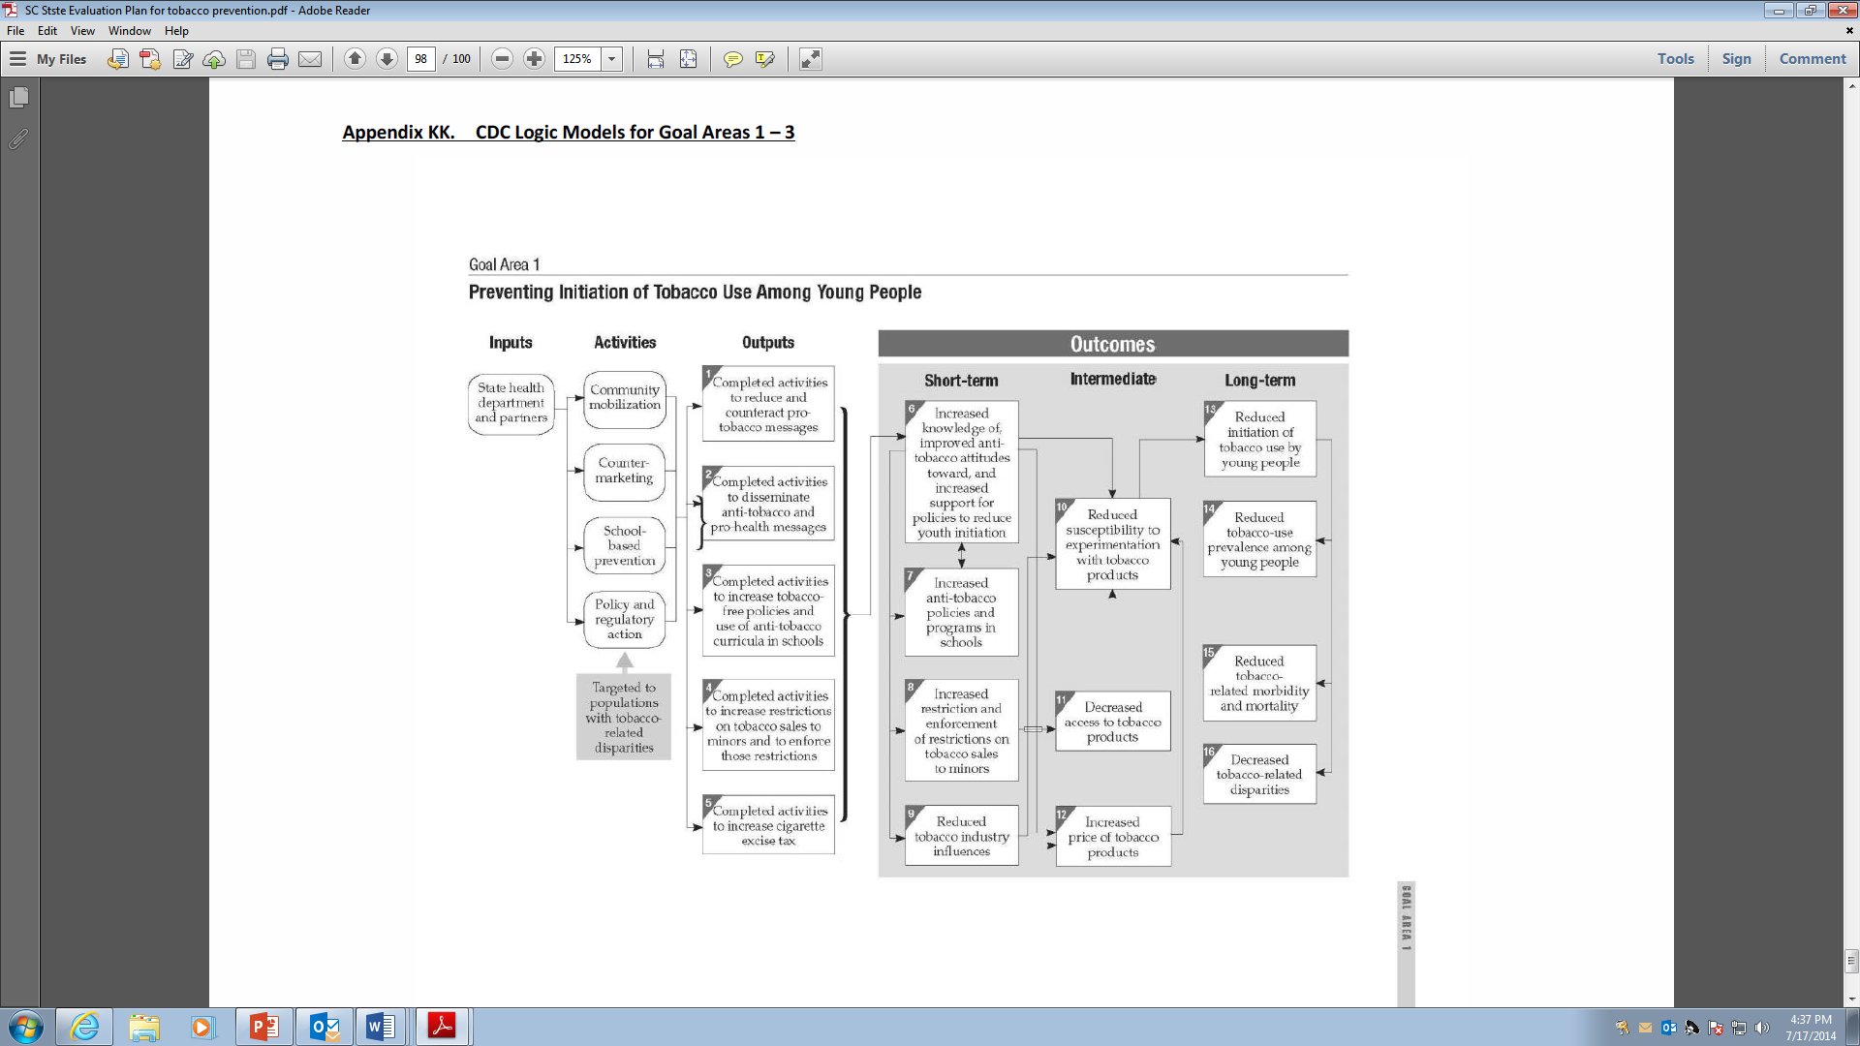

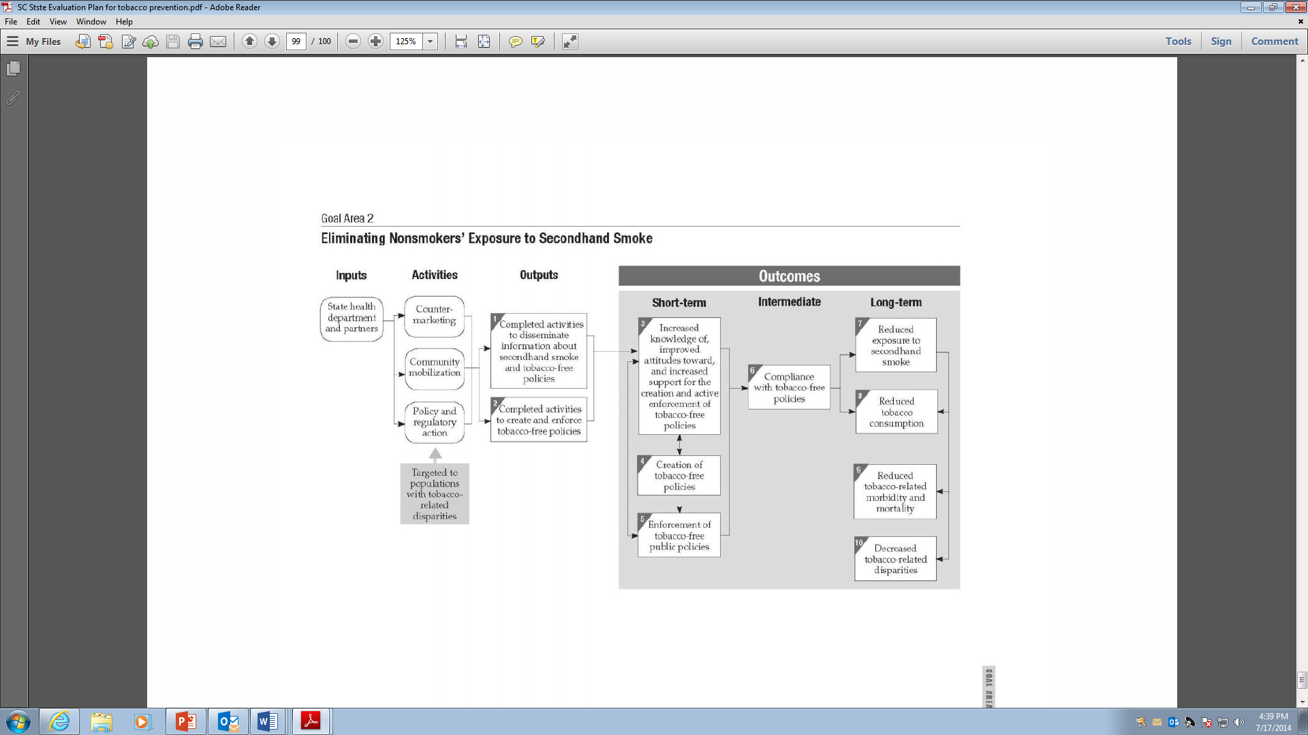

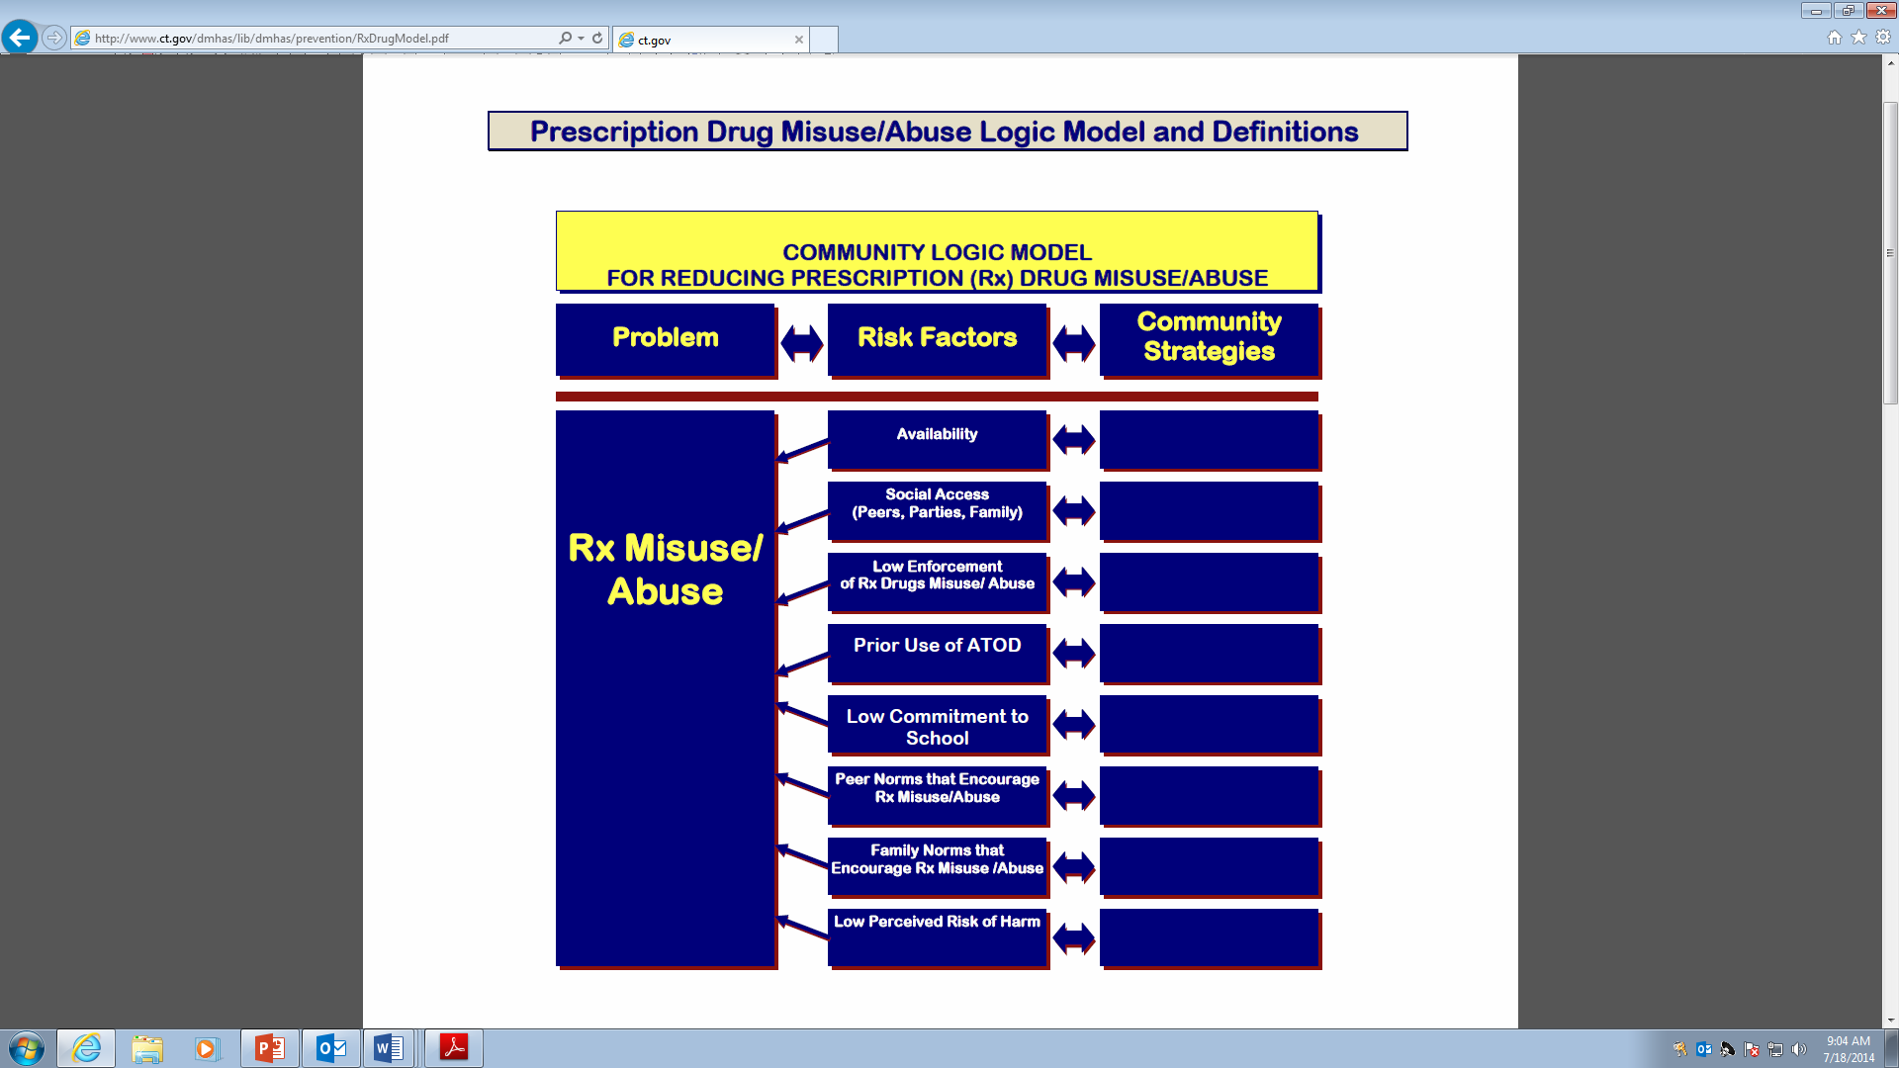

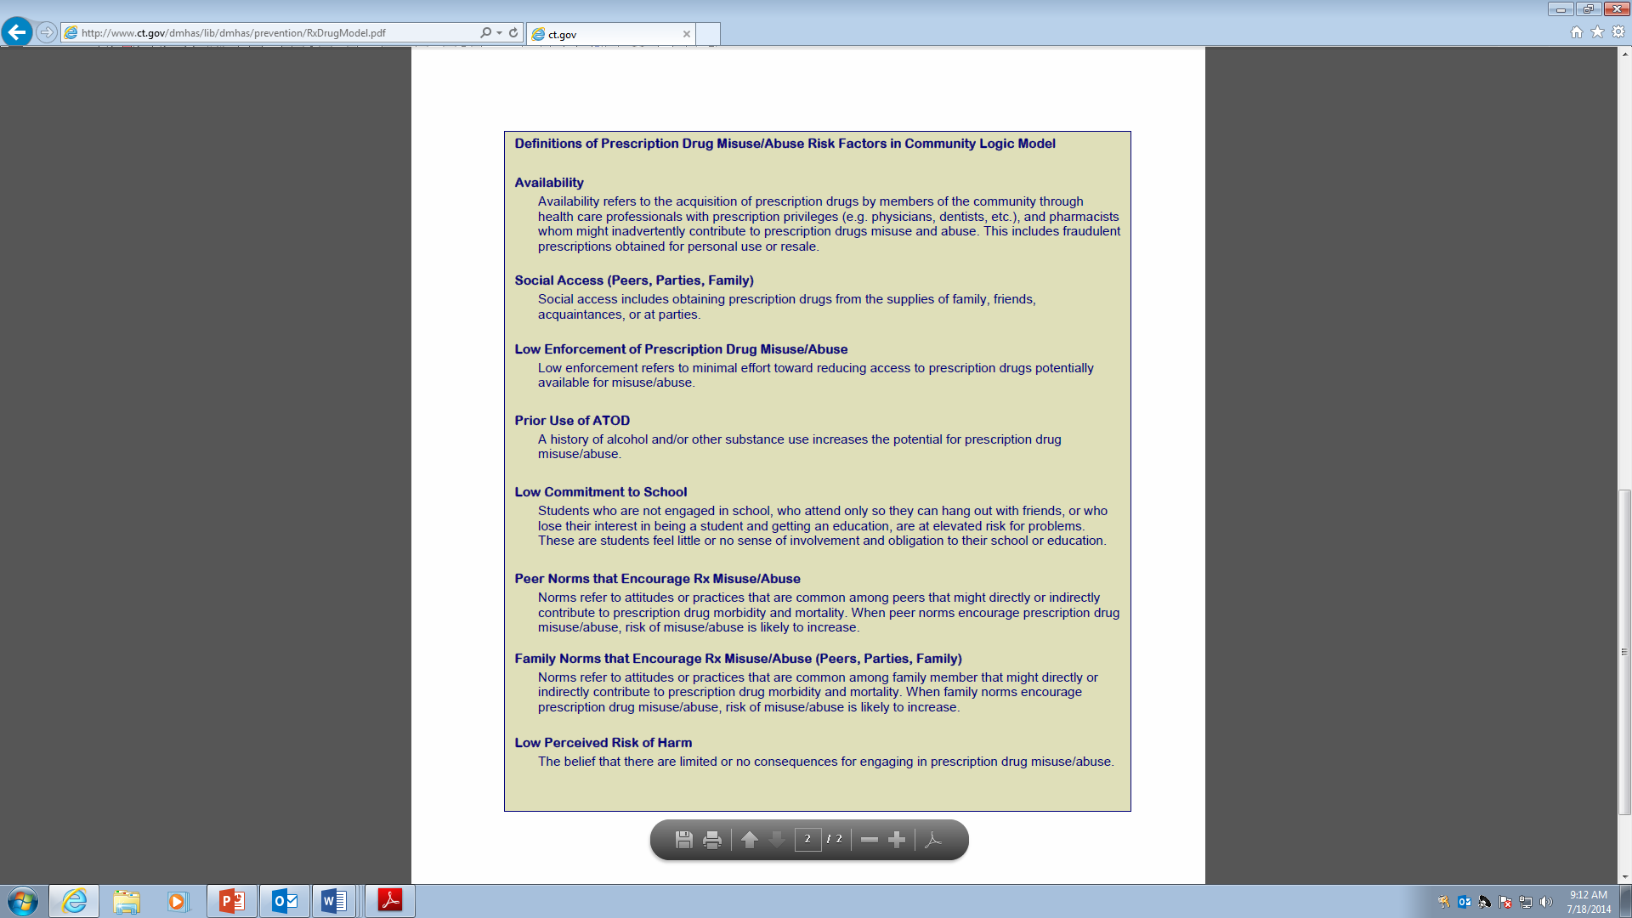

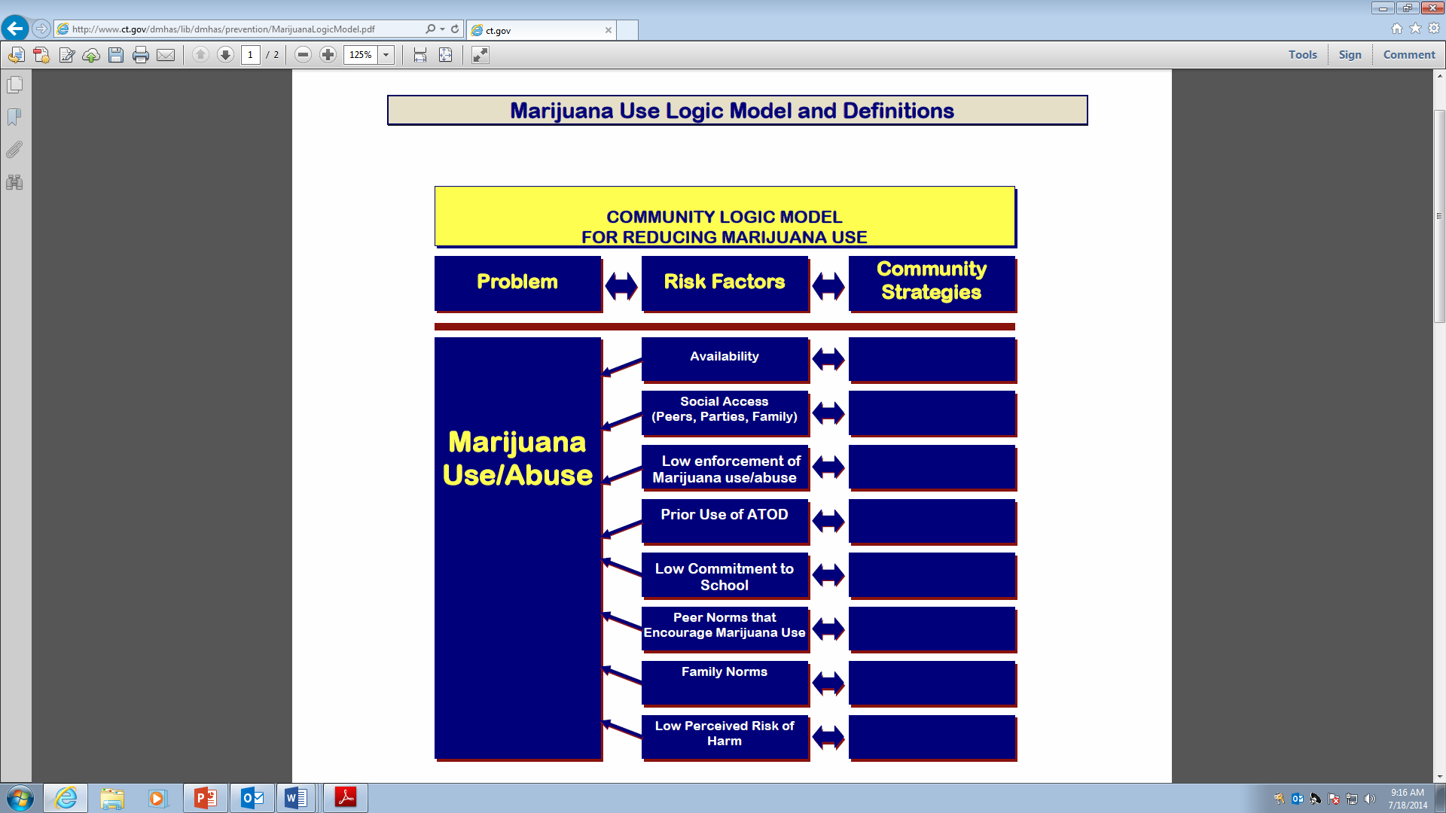

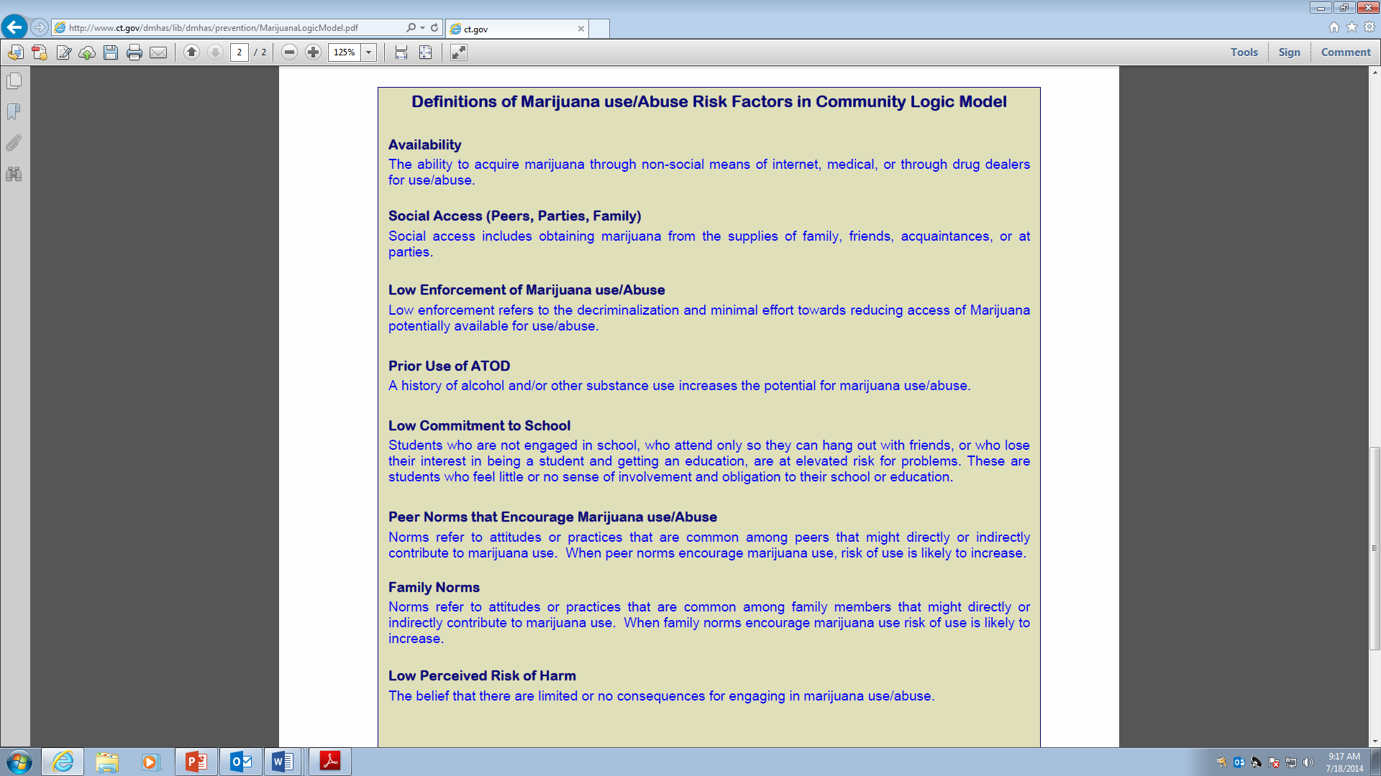

**Key Intermediate Variables Involved in Underage Drinking**

**UNDERAGE DRINKING**

**South Carolina Community Action for a Safer Tomorrow (CAST)**

**Environmental Logic Model: Underage Drinking**

Consumption Pattern

Risk Factors & Underlying Conditions

Environmental Strategies

**Social norms accepting and/or encouraging use**

**Insufficient enforcement of laws**

**Easy social access**

**Inappropriate promotion of use**

**Low or discount pricing**

**Insufficient enforcement of school policies**

**Easy retail access**

**Lack of identification of early problem behaviors**

**Underage Drinking**

**Social event monitoring & enforcement**

**High-visibility best practice enforcement operations**

**Adjudication systems enhancement**

**Merchant education**

**Alcohol advertising restrictions**

**Increase product price**

**Model school policies w/ enforcement**

**Improved screening &**

**referral systems**

**Insufficient laws and policies**

**Community mobilization for policy change**

* 35% of SC high school students drink
* 18% of SC high school students drank 5 or more drinks on one occasion in the past two week
* 1 in 10 SC high school students drove after drinking in the past month

**Community media advocacy**

Last updated 8/6/10

|  |  |  |  |
| --- | --- | --- | --- |
| **Risk factor/underlying condition** | **General description of risk factor/underlying condition** | **Possible contributing local factors** | **Possible strategies to employ** |
| Social norms accepting and/or encouraging use | Social norms can send a conscious or unconscious message to community members that underage alcohol use will be accepted. Those attitudes affect youth’s decisions and affect the environment that adults create for youth. Social norms could, however, discourage youth use. | * Alcohol access at social events * Lax enforcement of alcohol laws/policies * Community sectors’ (family, school, etc.) lack of attention/concern regarding underage drinking * Lack of local advocacy groups (e.g., drug-free or SADD youth groups) * Community practices that may involve alcohol (hunting, boating, tailgating, etc.) * Cultural practices or beliefs that may support alcohol use | * Social event monitoring & enforcement * High-visibility best practice enforcement operations * Community media advocacy |
| Insufficient enforcement of laws | Even when sufficient laws are in place, enforcement may not be adequately funded or equitably or properly enforced. Also, proper enforcement may exist, but the judicial system may not address offenders in a manner that the community expects. | * Lack of use of appropriate best practice enforcement operations * Lack of public awareness of enforcement * Insufficient levels of enforcement, overall or in a part of a county, due to lack of funding, training, or prioritization * In appropriate acceptance of plea bargaining * Failure to impose specified penalties/diversion programs * Insufficient communication b/w law enforcement and judicial officials on the required elements of a properly made case | * Social event monitoring & enforcement * High-visibility best practice enforcement operations * Adjudication systems enhancement * Community media advocacy |
| Easy social access | Social access includes receiving, stealing, or buying alcohol from friends, relatives, and strangers. Youth most frequently access alcohol through adults providing it for them or from inadequate controls on available alcohol. | * Adults providing alcohol to youth * Parties where ample alcohol is available to youth * Youth giving money to someone 21 or older to purchase them alcohol * Inadequate controls on alcohol present in the home or at social events * Inadequate restrictions on alcohol use at locations like beaches, parks, lakes, etc. * Sales at unlicensed establishments | * High-visibility best practice enforcement operations * Community media advocacy * Social event monitoring & enforcement |
| Easy retail access | Some youth obtain alcohol through direct purchase from a retail outlet (on- or off-premise), whether through use of a fake ID or improper actions by the establishment. When retail alcohol is cheap, convenient, and easily accessible, people drink more and the rates of alcohol problems are higher. | * Retailers selling to youth under 21 * Inadequate policies/procedures by retail establishments (e.g., failure to use electronic age verification equipment, having only bouncers check IDs, no age restrictions on sales staff) * High density of alcohol outlets * Use of fake IDs * Potential for direct online sales to youth | * High-visibility best practice enforcement operations * Merchant education * Community media advocacy |
| Inappropriate promotion of use | Messages promoting alcohol, whether intentionally or unintentionally directed at youth, are pervasive and influential. | * Happy Hour or other promotions that encourage excessive alcohol use * Messages glorifying alcohol use on the TV, radio, internet, etc. * Availability of youth-friendly products * Alcohol advertising that is appealing to youth or placed in places frequented by youth * Alcohol sponsorship of community events | * Alcohol advertising restrictions * Community media advocacy * High-visibility best practice enforcement operations |
| Low or discount pricing | The consumption of alcohol is affected by its price, especially for youth. Discounted drink specials encourage consumption. Some products that contain distilled spirits are taxed at the much lower beer tax rate. | * Happy Hour or other promotions that encourage excessive alcohol use * Low unit price of alcohol, particularly for products inappropriately taxed | * Increase product price * Community media advocacy |
| Insufficient laws and policies | Enforcement or regulators can be hindered by a lack of, or insufficient, laws, ordinances, regulations, or policies. | * Lack of effective laws/policies/ordinances, such as social host liability, “dram shop” liability, restrictions on outlet density, underage drinking courts, or Graduated Driver’s Licenses * Regulations that do not produce adequate controls or accountability on alcohol availability * Regulations that do not produce adequate controls over products with high alcohol content or that include energy-enhancing ingredients | * Community mobilization for policy change * Community media advocacy |
| Insufficient enforcement of school policies | Many school policies often do not incorporate the elements of model policies that have been developed. In addition, many policies are sufficient on paper but do not have the intended impact due to failure to implement fully or consistently. | * School policies that do not incorporate the key elements of model policies * Policies that are not carried out as written * Policies that address penalties only * Policies with penalties that do not adequately address the seriousness of the issue * Policies that do not include all school-related events and areas (e.g., class trips, athletic areas) | * Model school policies with enforcement * Community media advocacy |
| Lack of identification of early problem behaviors | Early underage drinking behaviors can often be identified by educated parents, school staff, etc. When underage drinking behavior is identified and it is not addressed sufficiently, an opportunity is missed to prevent future underage drinking and the consequences that often come with it. | * Low capacity of adults to identify signs of underage drinking by youth * Insufficient penalties, including those too lax, without an educational opportunity, or lacking follow through, when underage drinking is identified | * Improved screening and referral systems * Community media advocacy |

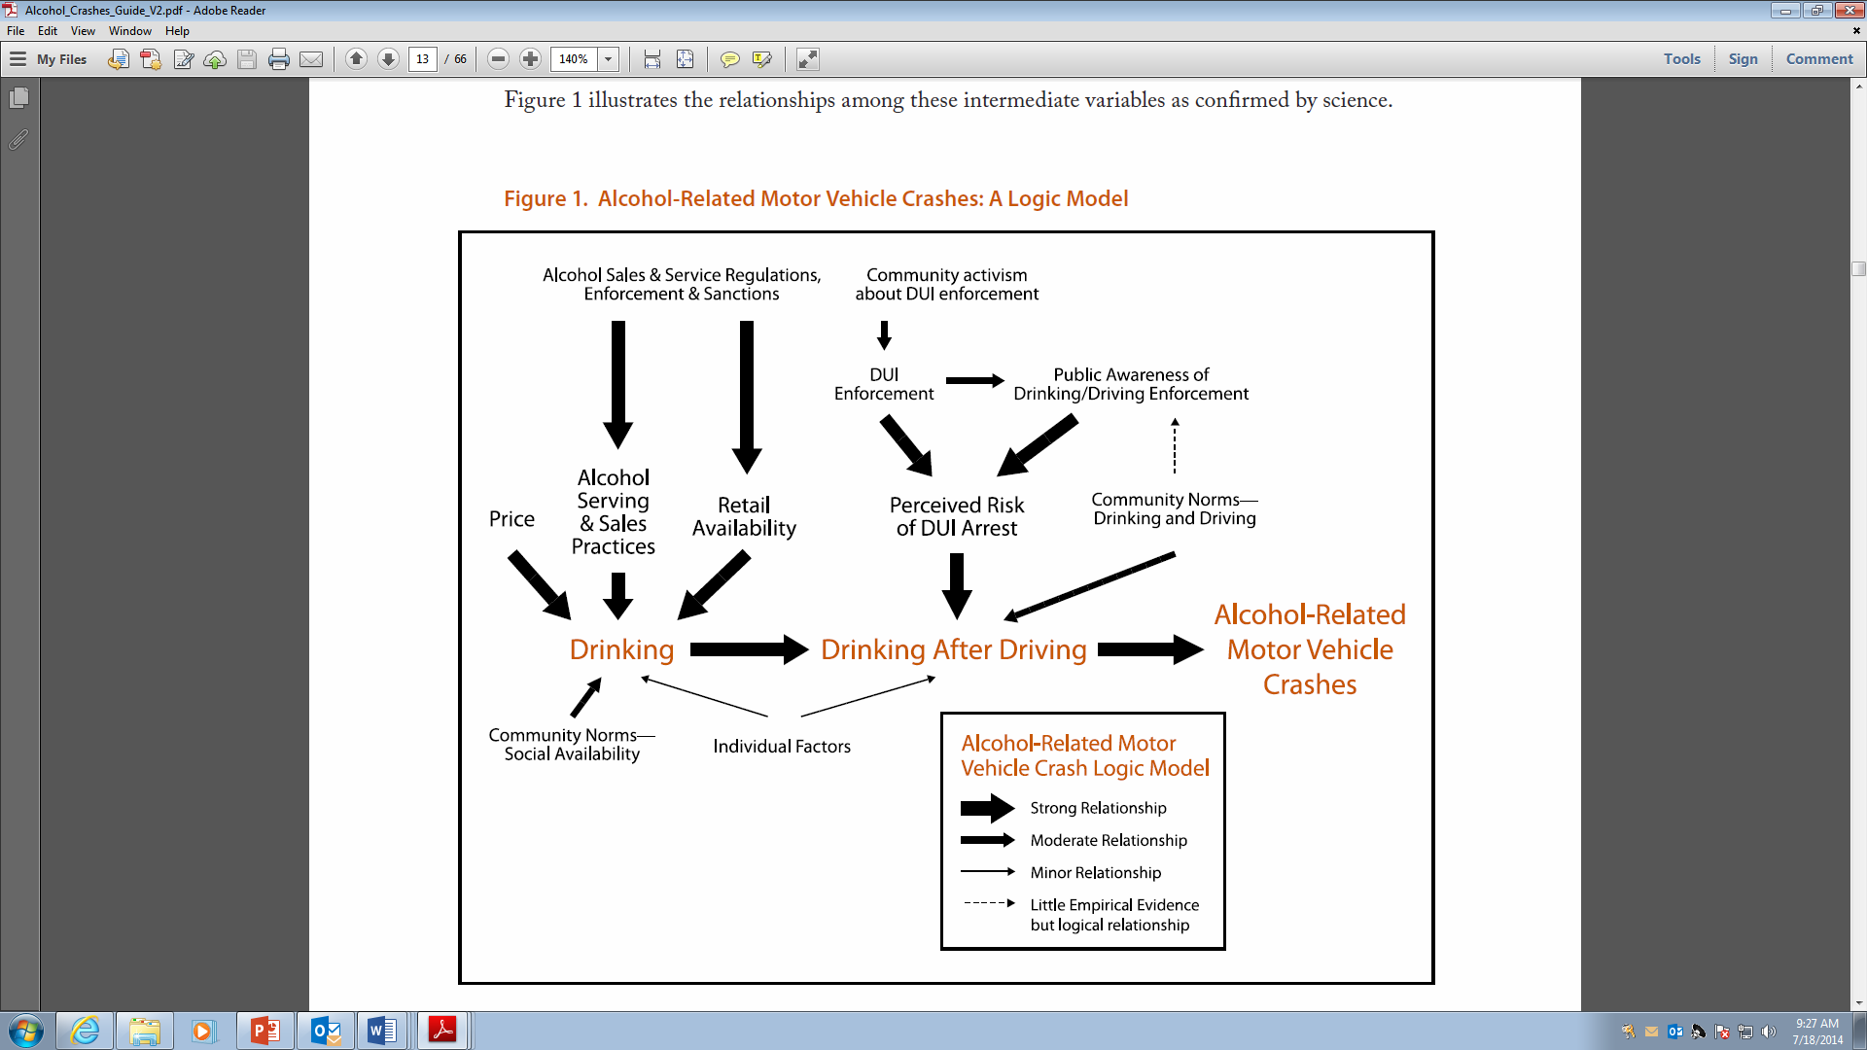

**DUI CRASHES**

**South Carolina Community Action for a Safer Tomorrow (CAST)**

**Environmental Logic Model: DUI Traffic Crashes**

Consumption Pattern

Risk Factors & Underlying Conditions

Environmental Strategies

**Social norms accepting and/or encouraging use**

**Insufficient enforcement of laws**

**Easy social access**

**Low or discount pricing**

**Over-service to intoxicated patrons**

**Insufficient laws and policies**

**DUI traffic crashes**

**High-visibility best practice enforcement operations**

**Adjudication systems enhancement**

**Merchant education**

**Restrictions on alcohol price/promotion**

**Social event monitoring & enforcement**

**Community mobilization for policy change**

Consequence

**Limited transportation options**

**Increase transportation options**

* The SC rate of 12.1 alcohol-related vehicle deaths per 100,000 people is almost twice the national rate
* Almost half of SC fatal motor vehicle accidents involve alcohol

**Drinking to the point of impairment**

**Lack of identification of problem behaviors**

**Improved screening & referral systems**

**Community media advocacy**

Last updated 8/6/10

|  |  |  |  |
| --- | --- | --- | --- |
| **Risk factor/underlying condition** | **General description of risk factor/underlying condition** | **Possible contributing local factors** | **Possible strategies to employ** |
| Lack of identification of problem behaviors | Many DUI offenders already have a DUI conviction. When an initial or subsequent charge does not lead to appropriate intervention, an opportunity is missed to prevent future drinking and driving and the consequences that often come with it. | * Insufficient screening processes in systems that could potentially identify those with drinking problems or inclinations to drive after drinking * Insufficient penalties, including those too lax or without a proper screening, treatment, or educational opportunity, or penalties lacking follow through | * Improved screening and referral systems * Community media advocacy |
| Insufficient enforcement of laws | Even when sufficient laws are in place, enforcement may not be adequately funded or equitably or properly enforced. Also, proper enforcement may exist, but the judicial system may not address offenders in a manner that the community expects. | * Lack of use of appropriate best practice enforcement operations * Insufficient levels of enforcement, overall or in a part of a county, due to lack of funding, training, or prioritization * Lack of public awareness of enforcement * Inappropriate acceptance of plea bargaining * Failure to impose or follow through on specified penalties/diversion programs * Inadequate support for prosecution * Insufficient communication b/w law enforcement and judicial officials on the required elements of a properly made case | * Adjudication systems enhancement * High-visibility best practice enforcement operations * Community media advocacy |
| Social norms accepting and/or encouraging use | Social norms send a conscious or unconscious message to community members that drinking and driving will be accepted. Those attitudes affect decisions and affect the environment in which those decisions are made. Social norms could, however, discourage drinking and driving. | * Alcohol access at social events * Lax enforcement of alcohol laws/policies * Perception of low penalties for offenders or low likelihood of conviction * Community sectors’ (family, school, etc.) lack of attention/concern regarding drinking and driving * Lack of local advocacy groups (e.g., MADD chapter, SADD club) * Community practices that may involve alcohol (hunting, boating, tailgating, etc.) * Cultural practices or beliefs that may support alcohol use | * High-visibility best practice enforcement operations * Social event monitoring & enforcement * Community media advocacy |
| Over-service to intoxicated patrons | State law forbids selling alcohol to an intoxicated patron, though it is rarely enforced, especially in on-premise establishments where some patrons will be driving home. Merchants may not adequately self-police, as well. | * Lax enforcement of sale to intoxicated patrons laws * Insufficient education or emphasis by retail establishments | * High-visibility best practice enforcement operations * Merchant education * Community media advocacy |
| Easy social access | Impaired drivers may be leaving social events where there was inadequate attention given to guests driving home intoxicated | * Inadequate controls on alcohol provided at social events * Sales at unlicensed establishments | * High-visibility best practice enforcement operations * Social event monitoring and enforcement * Community media advocacy |
| Low or discount pricing | The consumption of alcohol is affected by its price. Discounted drink specials encourage higher consumption. | * Happy Hour or other promotions that encourage excessive alcohol use * Low unit price of alcohol | * High-visibility best practice enforcement operations * Restrictions on alcohol price/promotion * Community media advocacy |
| Insufficient laws and policies | Enforcement or prosecution can be hindered by a lack of, or insufficient, laws, ordinances, regulations, or policies. | * Lack of effective laws/policies/ ordinances, such as restrictions on outlet density, DUI courts, or strong administrative license revocation provisions * Regulations that do not produce adequate controls or accountability on alcohol availability | * Community mobilization for policy change * Community media advocacy |
| Limited transportation options | When drinkers choose not to drive, their consumption does not raise the risk of crashes on the roadway. Availability of transportation options can help encourage drinkers not to drive. | * Poor accessibility to public transportation or paid transportation options (taxis, shuttles, etc.) * Insufficient or ineffective designated driver practices | * Increase transportation options * Community media advocacy |

**Appendix F: Data Collection Methods at a Glance**

|  |  |  |  |  |  |  |
| --- | --- | --- | --- | --- | --- | --- |
| **Method** | **Pros** | **Cons** | **Costs** | **Time to Complete** | **Response Rate** | **Expertise Needed** |
| Interviews – face to face and open ended | Gather in-depth, detailed info.; info. can be used to generate survey questions | Takes much time and expertise to conduct and analyze; potential interview bias possible | Inexpensive if done in house; can be expensive to hire interviewers and/or transcribers | About 45 min. per interview; analysis can be lengthy depending on method | People usually agree if it fits into their schedule | Requires good interview/conversation skills; formal analysis methods are difficult to learn |
| Open-ended questions on a written survey | Can add more in-depth, detailed info. to a structured survey | People often do not answer them; may be difficult to interpret meaning of written statements | Inexpensive | Only adds a few more minutes to a written survey; quick analysis time | Moderate to low | Easy to content analyze |
| Focus groups | Can quickly get info. about needs, community attitudes and norms; info. can be used to generate survey questions | Can be difficult to run (need a good facilitator) and analyze; may be hard to gather 6 to 8 people together | Inexpensive if done in house; can be expensive to hire facilitator | Groups themselves last about 1.5 hours | People usually agree if it fits into their schedule | Requires good interview/conversation skills; technical aspects can be learned easily |
| Self-administered surveys (paper, web-based) | Anonymous; inexpensive; easy to analyze; standardized, so easy to compare with other data | Results are easily biased; misses info.; drop out is a problem for analysis | Moderate | Moderate, but depends on system (mail, distribute at school) | Moderate, but depends on system (mail has the lowest) | Little expertise needed to give out surveys; some expertise needed to analyze and interpret the data |
| Face-to-face structured surveys | Same as paper and pencil, but you can clarify responses | Same as paper and pencil but requires more time and staff time | More than telephone and self-administered surveys | Moderate to high | More than self-administered survey (same as telephone survey) | Need some expertise to implement a survey and to analyze and interpret the data |
| Archival trend data | Quick; inexpensive; a lot of data available | Comparisons can be difficult; may not show change over time | Inexpensive | Quick | Usually very good but depend on the study that collected them | No expertise needed to gather archival data, some expertise needed to analyze and interpret the data |
| Record review | Objective; quick; does not require program staff or participants; preexisting | Can be difficult to interpret, often is incomplete | Inexpensive | Time consuming | Not an issue | Little expertise needed; coding scheme may need to be developed |

**Appendix G: Resources for Human Subjects**

An Institutional Review Board (IRB) helps to ensure that research involving human subjects will not create undue harm or burden on the people involved. It also ensures that confidential information is protected and secure, and that participants are properly informed of their rights, the purpose of the research and that they can refuse to participate at any time.

Determining whether something is research that involves human subjects can be surprisingly complicated and depends on a variety of factors. There are a number of questions to think about as you determine whether you will need IRB approval:

1. 1. Do you intend to collect information and then present it to a public audience or at a conference?
2. 2. Do you intend to publish findings or disseminate information based upon your work?
3. 3. Will you be conducting interviews, surveys or focus groups?
4. 4. Will you need access to sensitive data or records?
5. 5. Is there any way to link the data you plan to collect with identifying information?
6. 6. Are you seeking grant funding?

If the answer to any of these questions is "yes" your work **may** require IRB review. The following website includes decision charts that can also help you decide if you need to contact an IRB for more guidance:

http://www.hhs.gov/ohrp/humansubjects/guidance/decisioncharts.htm#c1

The Bureau of Substance Abuse and Addiction Services can help decide if you need to have an IRB review your evaluation protocols (surveys, focus group questions and procedures, etc.). The IRB may also issue Exemption reviews, meaning they will confirm that your work does not meet the requirements that would necessitate a full review. For more information, visit the Michigan Department of Community Health’s IRB website: http://www.michigan.gov/mdch/0,1607,7-132-2945_32550---,00.html.

**Appendix H: Creating a Survey**

Although there are volumes written about how to design and administer surveys, The American Statistical Association has several brochures about survey research on its web site, http://www.amstat.org/sections/srms/whatsurvey.html, including the following:

* How to plan a survey.
* How to collect survey data.
* Designing a questionnaire (another name for a survey).
* Telephone surveys.
* Mail surveys.
* Pre-testing surveys (administering the survey to a few people to work out the bugs).

It is best to use existing instruments, if available and cost effective, as they have already been tested for reliability and validity. However, you may choose to develop your own survey. The following are guidelines to consider:

* Be brief
* Use simple and grammatically correct language
* Watch out for words with double meanings or words that are easily confused
* Avoid complex sentences
* Avoid negative questions (do you not like…)
* Minimize yes/no questions
* When asking people to rate their agreement with a statement or rate their opinion, use at least a five point rating system, i.e., a scale of 1 to 5 and define what the numbers mean. This is commonly referred to as a Likert scale.
  + Define what *each* level of the scale means (e.g., 1= poor, 2= fair, 3= good, 4= very good, 5= excellent).
  + Repeat the scale if you continue beyond original page
* Be sensitive to minority or subculture groups and with personal items
* Keep questions and corresponding answers on the same page
* Group similar response formats and themes together
* Consider what demographic information you need and how it will be useful. If you don’t need it, don’t ask for it.
* Consider spacing and layout (e.g., easy to read, pleasant in appearance, indent answers separately from questions). If using a web survey, consider breaking it up into several pages.
* Consider use of graphics, words of encouragement, thank you at the end
* Do not use abbreviations or acronyms unless you define them (e.g., Qty, RBS).
* Whenever possible, include an “other” category with a blank space for respondents to provide more information (e.g., Other, please specify:______________)
* Use judgment about using complex formats (e.g., if you answer no, go to question #...)
* Pilot the instrument to get feedback and make adjustments before full implementation.

**Appendix I: Human Environmental Framework**

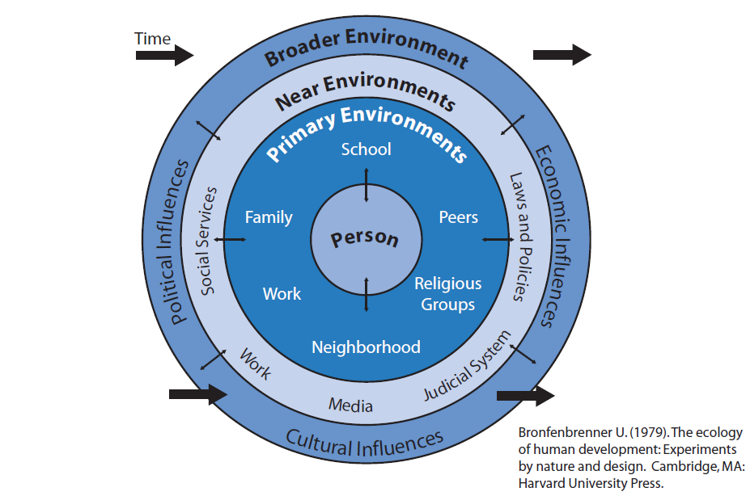

This figure depicts social influences in circles moving progressively away from direct influence on the individual toward increasingly indirect influence while advancing over time. A comprehensive needs assessment plan should identify a mix of data collection methods that assess risk and protective factors in multiple contexts across the lifespan.

1. Material in this section is drawn from the following sources:

   Center for Substance Abuse Prevention, "SPF SIG Overview and Expectations." New Grantee Workshop; and Lowther, Mike and Johanna D. Birckmayer. "Outcomes-Based Prevention." Multi-State Technical Assistance Workshop. Washington, DC. March 16, 2006.
2. If collecting original data, please remember to consider any applicable human subjects requirements. See Appendix G.
3. Adapted from “How Do We Know We Are Making A Difference? A Community Alcohol, Tobacco, and Drug Indicators Handbook” Boston, MA: Join Together, 2005.
4. Because the contributing local factor is more detailed, you should prioritize at this level, rather than the risk factor and underlying condition level.